# CS 255 System Design Document Template

This template lays out all the different sections that you need to complete for Project Two. Each section has guidance to prompt your thinking. You will need to continually reference the interview transcript as you work to make sure that you are addressing your client’s needs. There is no required length for the final document. Instead the goal is to complete each section based on what your client’s needs are. Remove this note when you are finished, and replace all bracketed text with the relevant information.

## UML Diagrams

### UML Use Case Diagram

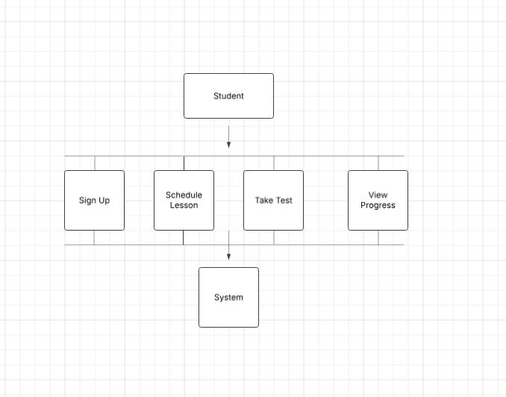

### UML Activity Diagrams

*[You were asked to choose* ***two*** *use cases and create* ***two*** *activity diagrams, one for each use case. Please insert* ***both*** *of your activity diagrams here. Check to make sure that you included appropriate components and symbols and that your design meets the client’s needs.]*

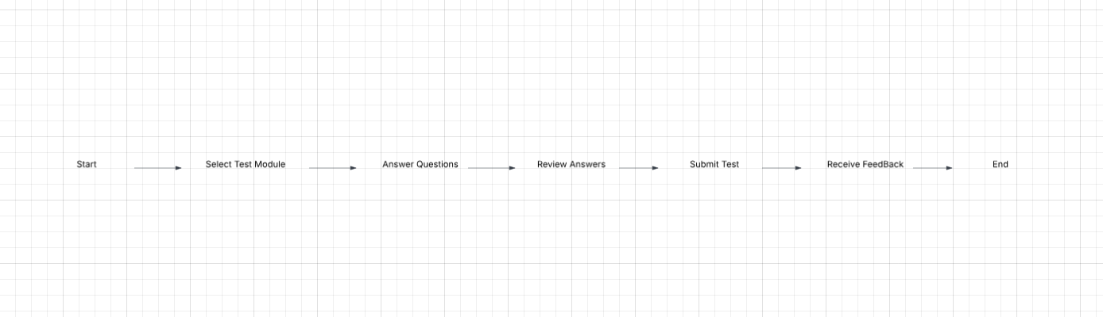

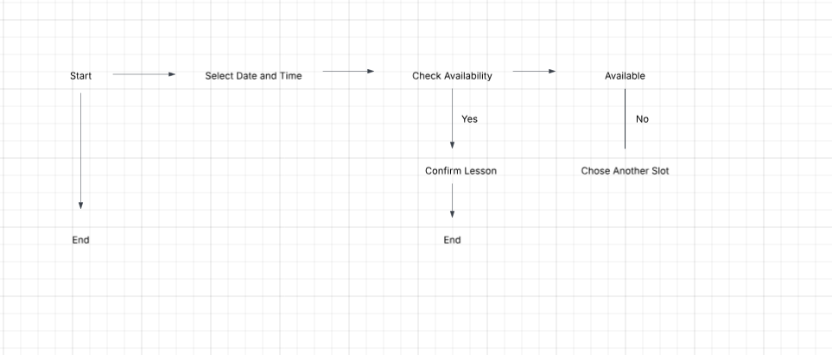

### UML Sequence Diagram

*[You were asked to create a sequence diagram based on* ***one*** *of the use cases you chose. Please insert your sequence diagram here. Check to make sure that you included appropriate components and symbols and that your design meets the client’s needs.]*

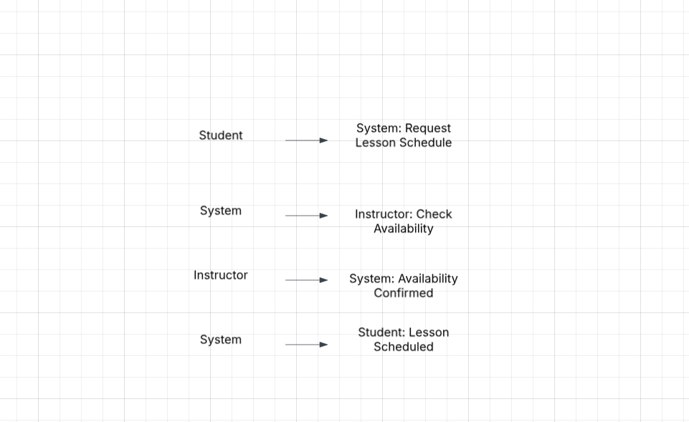

### UML Class Diagram

*[You were asked to create a class diagram based on the different classes and attributes needed for your system design. You are* ***not*** *required to include methods, but you may if you wish. Please insert your class diagram here. Check to make sure that you included appropriate components and symbols and that your design meets the client’s requirements.]*

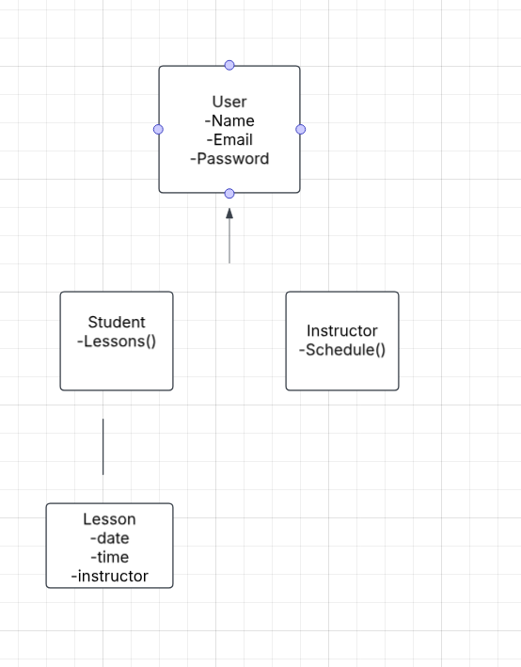

## Technical Requirements

The DriverPass system would require a cloud-based server with high availability to handle any online access along with data storage. Clients would use devices such as desktops, laptops, tablets, and smartphones that must be compatible with the system. The system would run on Windows, macOS, and Linux servers. Reliable internet access is necessary for all administrators and clients to receive the most up to date schedules, reservations, and policy changes submitted by the DMV. Security is a big one of course and will be backed by Role-based access control.